|  |  |
| --- | --- |
| Lab 3 | |
| ECE 380 W21 | |
| Group 8 | |
| Arjun Bawa, a3bawa | Andrew Tran, a89tran |

Table of Contents

Declaration of Authorship 3

3.1 to 3.3 4

3.4 5

3.5 6

3.6 7

3.7 8

3.8 9

1 9

2 & 3 10

4 11

# Declaration of Authorship

We acknowledge and promise that:

1. We are the sole authors of this lab report and associated simulation files/code.
2. This work represents our original work.
3. We have not shared detailed analysis or detailed design results, computer code, or Simulink diagrams with any other student.
4. We have not obtained or looked at lab reports from any other current or former student of ECE/SE 380, and we have not let any other student access any part of our lab work.
5. We have completely and unambiguously acknowledged and referenced all persons and aids used to help us with our work.

|  |  |
| --- | --- |
| Student1 Name and Signature:  **Arjun Bawa** | Student2 Name and Signature:  **Andrew Tran** |

# 3.1 to 3.3

Time constant = 16s

# 3.4

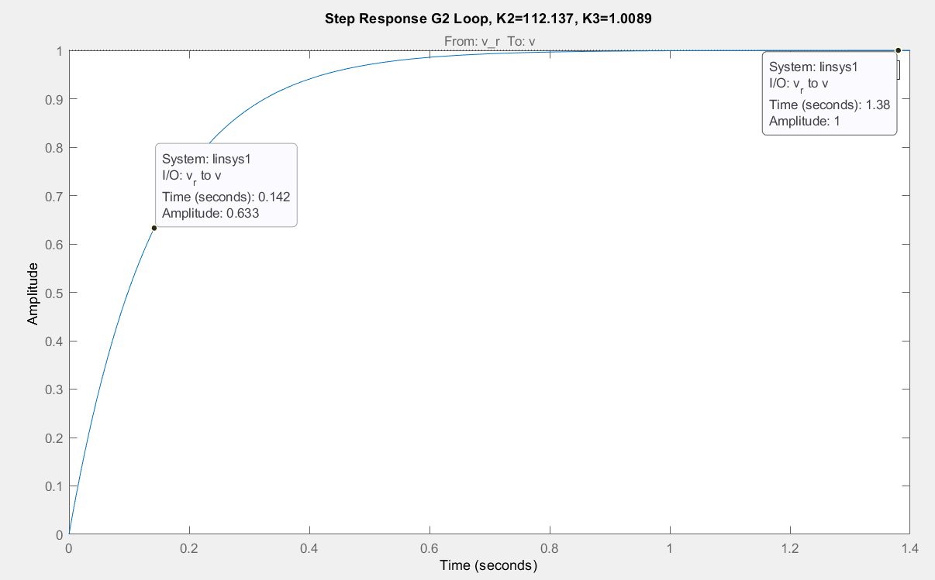

# 3.5

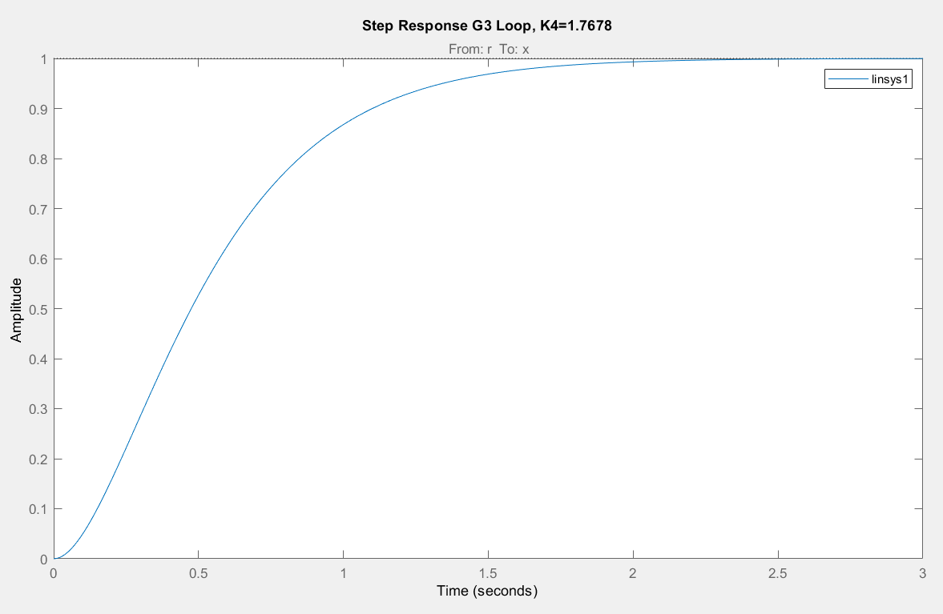

# 3.6

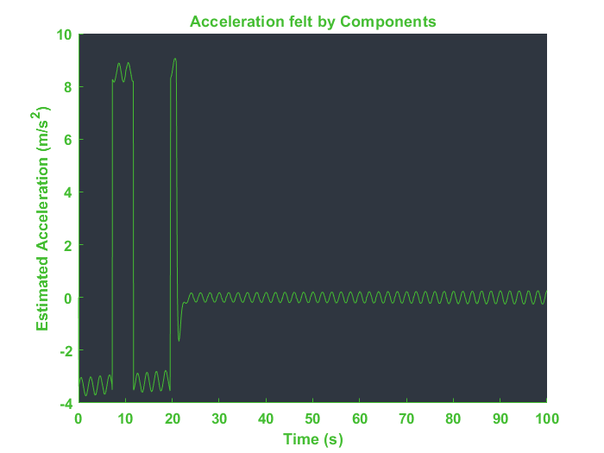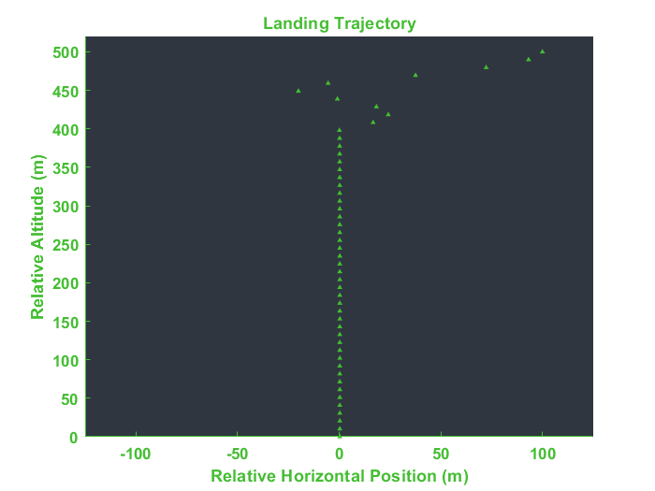

# 3.7

# 3.8

## 1

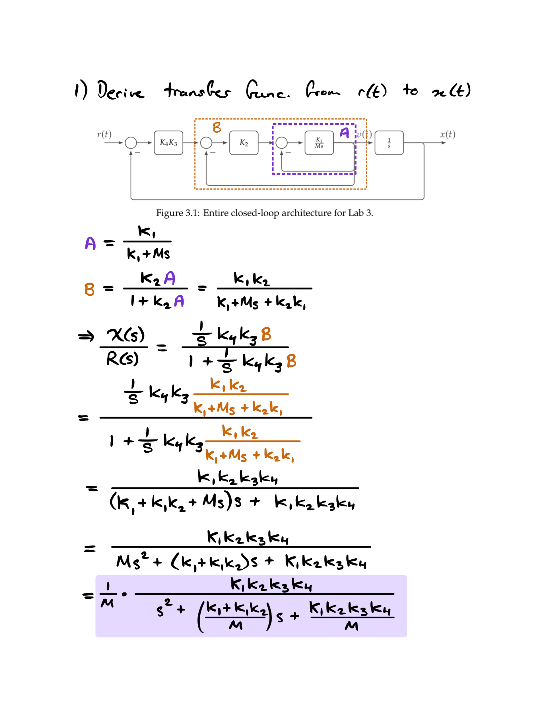

## 2 & 3

## 4

